System and Program Design

INTRODUCTION

Inventory Management is one of the basic problems for a

company. It may cause a lot of paperwork, if there is no au-

tomated system available. Implementing such a system is

possible but there are a lot of preliminary works such as de-

termination of the requirements, system structure decision –

software requirements, barcode system selection and deter-

mination of the software tools

INTRODUCTION

Inventory Management is one of the basic problems for a

company. It may cause a lot of paperwork, if there is no au-

tomated system available. Implementing such a system is

possible but there are a lot of preliminary works such as de-

termination of the requirements, system structure decision –

software requirements, barcode system selection and deter-

mination of the software tools

**Introduction**

Inventory Management is one of the basic problems for a company. It may cause a lot of paperwork, if there is no automated system available. Implementing such a system is possible but there are a lot of preliminary works. This project is used mainly for medical stores to maintain the details of medical store such as stock and account. This medical shop management software is so designed as to ease the work load of medical shop professionals. The main feature includes inventory and stock control, accounting, client management.

**Solutions**

* Problem to maintain record of daily transactions.
* They have Work load so they Also have problem in dealing with their customer
* At the End they also have problem in calculating their profit, sales, Purchases etc.
* They also have problem to find a specific product

**Scope & Objectives**

As this is generic software it can be used by a wide variety of outlets (Retailers and Wholesalers) to automate the process of manually maintaining the records related to the subject of maintaining the stock and cash flows. This project is basically updating the manual chemist inventory System to Automated inventory system, So that organization can manage their record in efficient and organized form.

* This software helps you to track all the products of medical shop moreover it’s a medical shop accounting software. Flexible and adaptive software suited to medical shops or stores or pharmacies of any size.

**Modules**

1. Customer Management
2. Transaction Management
3. Inventory Management
4. Purchase & Sales Management
5. Stocks
6. Reports

* The main goal of the application is to maintain the records of purchase, Sales and stock details with cash transaction maintenance.
* Medical Store Management software is very needy for Medical Store. This software help them maintain day to day transactions in computer.

**Model Implementation**

**Iterative** model is used to develop this project. The iterative model is a particular implementation of a software development life cycle (SDLC) that focuses on an initial, simplified implementation, which then progressively gains more complexity and a broader feature set until the final system is complete. This model is used when the requirements of the complete system are clearly defined and understood. The major requirements are defined, while some functionalities and requested enhancements evolve with the process of the development process.

**Reason & Justification**

We review the prototype with our client on each layer and test it to improve the understanding client’s needs and clarify the design. If the client approves, only then we move forward to the next step. If we complete the whole project without reviewing it to the client and the final product is not up to client’s expectations, the whole process will be for nothing. We would have to redo the project. Whereas, using iterative model, it helps us with the client’s feedback and help us improve things without an additional cost until the final product is achieved.

**Iterative Refinement Model**

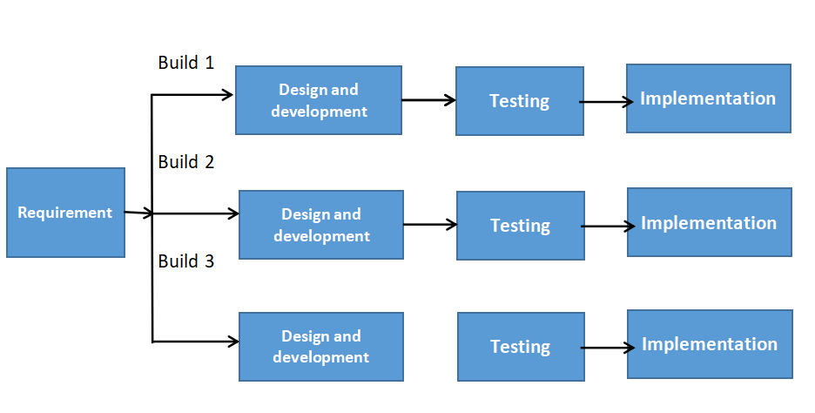

**Component Diagram**

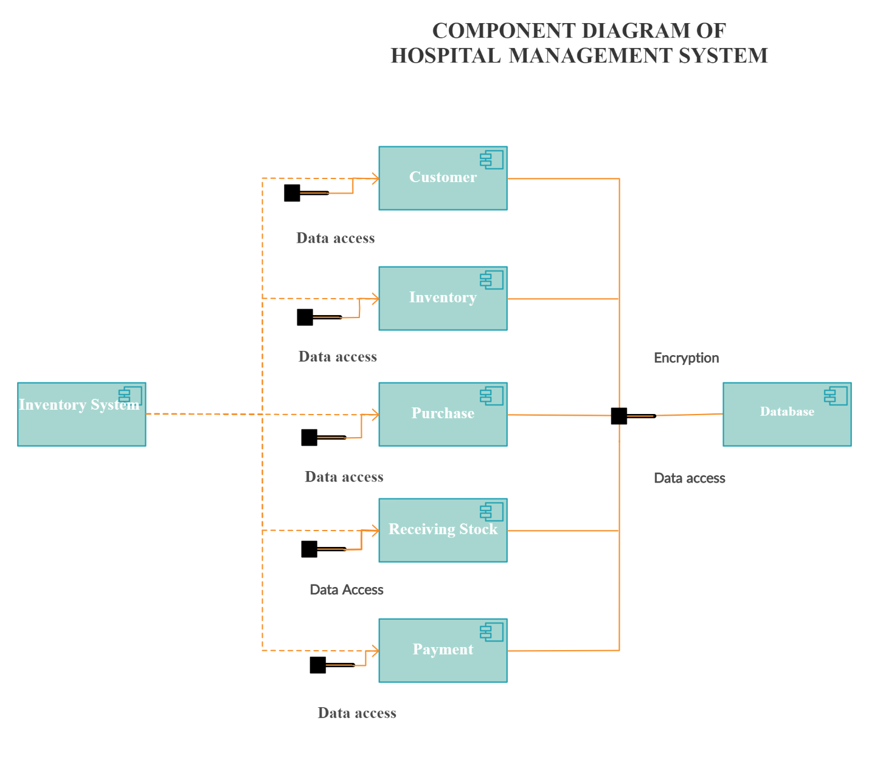

**Deployment Diagram**

Inventory management consists of the ability to retrieve, store, and report hardware and software information for assets within an organization. This information can be as detailed as tracking a specific DLL file for all users of an application.

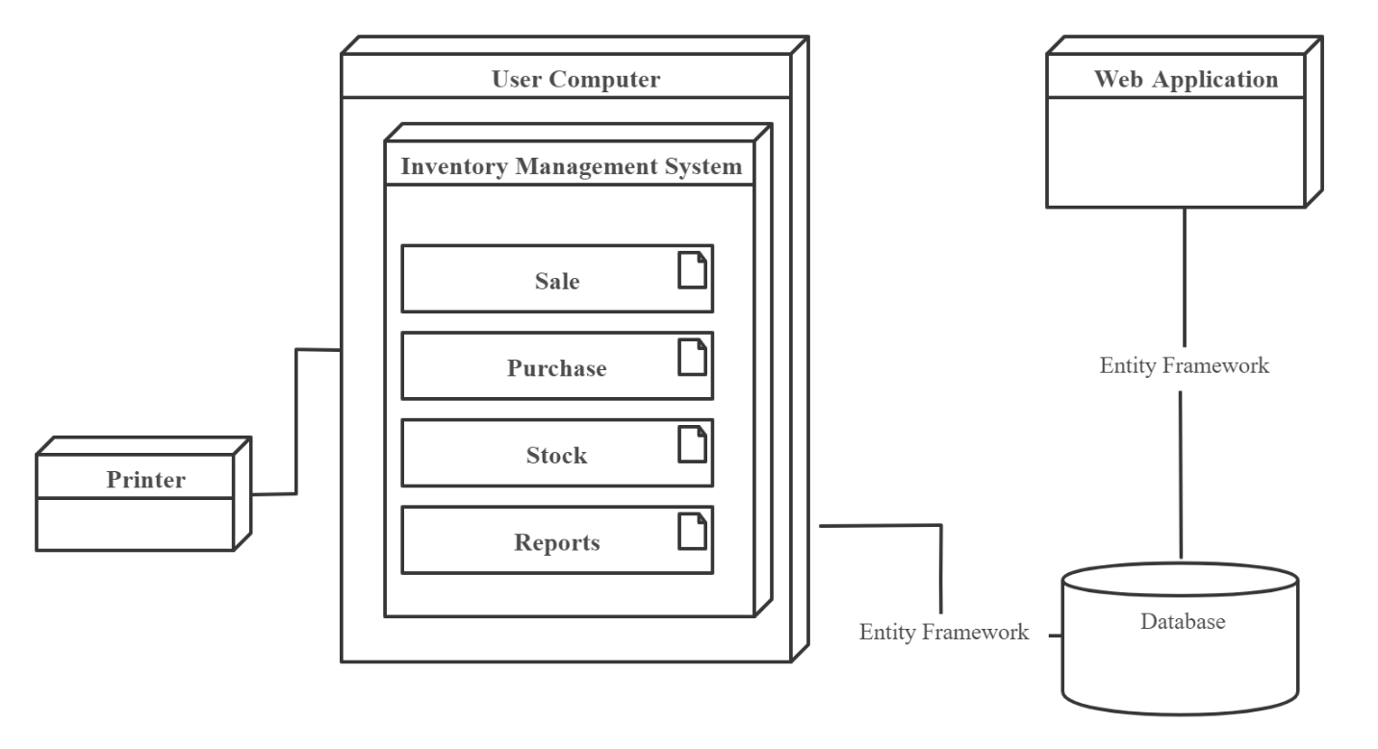

**Context Diagram / Data Flow**

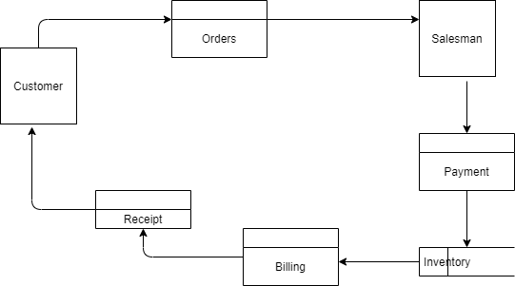

**Software Requirement**

**Purpose**

This document outlines the software requirements for the Inventory management system for the Sidra Medical Store. It describes the functional and non-functional requirements, modeling requirements, diagrams and user profiles of the proposed system. The Inventory Management System enables the staff to maintain computerized Record of Customer Who visits, their Employees & product. It also performs quick search for their products, Manages Counter sales and keep record. This Software requirement provides detailed information on the internal and external view of the system as well as interfaces required by management System.

* **Administrator**: A log in Id representing the user with user administration privileges To Software.
* **Client**: Intend user of Software.

**Operating Environment / Tools**

* **Language**: HTML, CSS, JQuery
* **Platform:** vb.net
* **Database**: Local database in vb

**Project Features**

There will be two-user Accessing System Software

**Manager**: Who will act As Administrator.

* Add, delete and update any product
* Manage store i.e. (put price, Calculate Revenue, generate reports)

**Staff (User)**: Who will access the System.

* Cashier can search the product and make the bill
* Can see the list of product

**User Manual**

This project will include a **user manual**. The user manual include Complete overview of the products ,Configuration of the Tool used, technical details, backup procedures and Contact Information which will include email address. The user manual, installation guide and other related material should be sufficient to educate the user how to use and maintain the system.

of the software too